Graphic Aides  
04/02/2012

**Student Name: ___________________________**

**Class: ___________________________**

**Date: ___________________________**

**Instructions: Read each question carefully and select the correct answer.**

Read the following information. Then, answer the questions that follow.  
  
Kendra Tyler Anderson was born on July 9, 1990. Several months ago, she applied for a social security card. Her social security number is 123-45-6789. She lives with her family at 15 Oceanview Way in La Mar, California. The zip code there is 90101.  
  
Kendra and her grandmother like to go fishing down at the lake. Because a new fishing law was passed in her town, Kendra needs to apply for a fishing license before she can fish this year.  
  
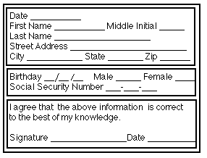

**1.** Use the information you just read about Kendra to answer the question.  
  
When did Kendra apply for a social security card?

**A.** Kendra applied for a social security card several months ago.

**B.** Kendra applied for a social security card on July 9, 1990.

**C.** Kendra applied for a social security card on her birthday last year.

**D.** Kendra has not applied for a social security card.

**2.** Use the information you just read about Kendra to answer the question.  
  
With whom does Kendra live?

**A.** her grandmother

**B.** her family

**C.** no one

**D.** information not provided

**3.** Use the information you just read about Kendra to answer the question.  
  
Kendra is _________.

**A.** a female

**B.** a teenagers

**C.** a good student

**D.** in the seventh grade

**4.** Use the information you just read about Kendra to answer the question.  
  
What would Kendra write on the line following Middle Initial?

**A.** Tyler

**B.** Kendra Tyler Anderson

**C.** T.

**D.** K. T. A.

**5.** Use the announcement to answer the question.  
  
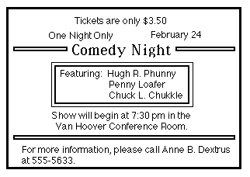  
On what day of the week is the show?

**A.** February 24

**B.** January 24

**C.** Tuesday

**D.** information not provided

**6.** Use the announcement to answer the question.  
  
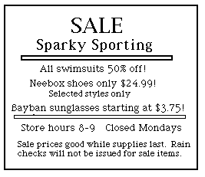  
When is the store open?

**A.** Tuesday through Sunday from 8 a.m. to 9 p.m.

**B.** every day from 8 a.m. to 9 p.m.

**C.** Monday through Saturday from 8 a.m. to 9 p.m.

**D.** information not provided on advertisement

**7.** Use the announcement to answer the question.  
  
  
Which of the following is not a performer?

**A.** Hugh R. Phunny

**B.** Anne B. Dextrus

**C.** Penny Loafer

**D.** Chuck L. Chukkle

**8.** Use the announcement to answer the question.  
  
  
How many nights is the comedy running?

**A.** 1

**B.** 3

**C.** 24

**D.** information not provided

**9.** Wendy McDonald created this table to compare food prices at four fast-food restaurants. Use the table to answer the question.  
  
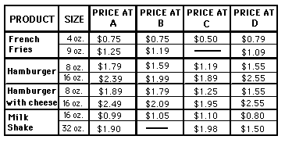  
How much is a sixteen-ounce hamburger with cheese at Restaurant C?

**A.** $2.55

**B.** $1.59

**C.** $1.25

**D.** $1.95

**10.** Wendy McDonald created this table to compare food prices at four fast food restaurants. Use the table to answer the question.  
  
  
Which restaurants sell a sixteen-ounce hamburger for less than two dollars?

**A.** B and C

**B.** C and D

**C.** A and D

**D.** A and B

**11.** Wendy McDonald created this table to compare food prices at four fast-food restaurants. Use the table to answer the question.  
  
  
Which restaurant sells the most expensive sixteen-ounce hamburger?

**A.** A

**B.** B

**C.** C

**D.** D

**12.** Wendy McDonald created this table to compare food prices at four fast food restaurants. Use the table to answer the question.  
  
  
Which restaurant has the lowest price on a thirty-two-ounce milk shake?

**A.** A

**B.** B

**C.** C

**D.** D

**13.** Use the map to fill in the blank.  
  
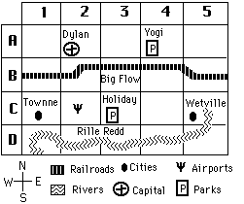  
According to the map, the airport is located _________ of Dylan.

**A.** north

**B.** south

**C.** east

**D.** west

**14.** Use the map to answer the question.  
  
  
How many parks are on the map?

**A.** zero parks

**B.** one park

**C.** two parks

**D.** three parks

**15.** Use the map to answer the question.  
  
  
According to the map, what is the name of the park that is located southeast of Dylan?

**A.** Townne

**B.** Yogi

**C.** Big Flow

**D.** Holiday

**16.** Use the map to answer the question.  
  
  
According to the map, what is the name of the railroad?

**A.** Holiday

**B.** Wetville

**C.** Big Flow

**D.** Rille Redd